User management and audit logs in Prisma cloud

For User management below are the steps

Step 1: Login to Prisma cloud using: <https://app.ind.prismacloud.io/login>

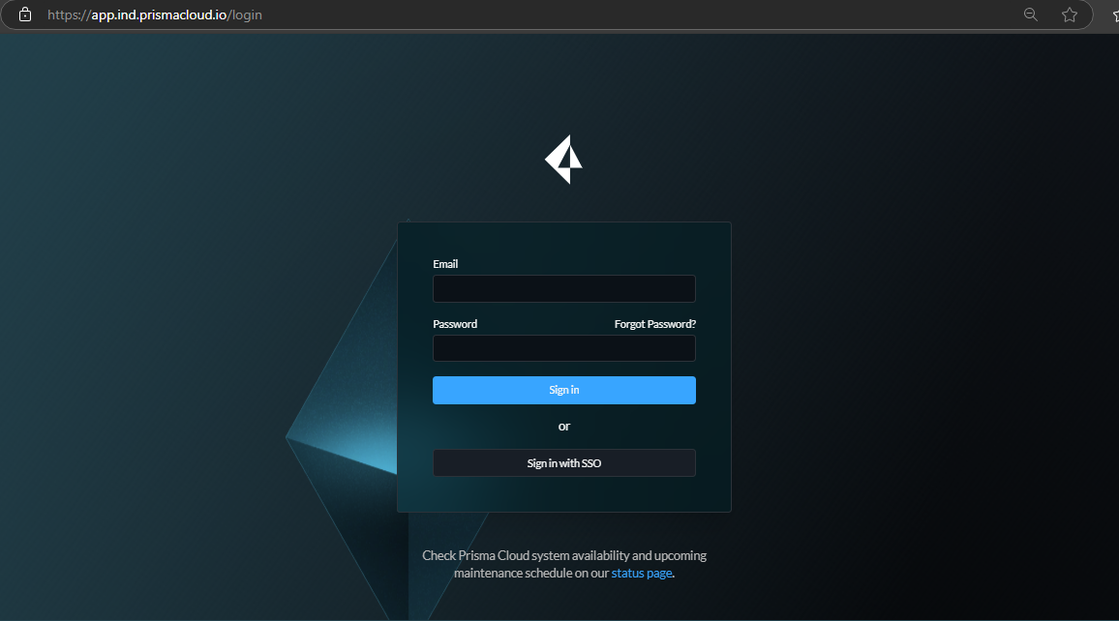

Step 2: Click on Settings

Step 3: Click on “Access control” tab, different entities can be created such as roles, users, access keys and SSOs. Click on “Add” and then on “User”.

Step 4: Add the details like, email id, first name and last name. In the dropdown menu of Assign role, only select the roles which are required and ensure least privilege access.

Step 5: Once the role is selected, verify default role and click on “Save and close”. Once the users is created successfully, invitation email will be sent the mentioned email-id.

For audit logs in Prisma cloud

Step 1: Go to the “Settings” and navigate to “Audit logs” tab.

